**Back pain, head pain**

**Initial Assessment**

|  |  |  |
| --- | --- | --- |
| **Presenting Symptom/Chief Complaint** | | |
| Patient is complaining of back and head pain after the accident. Low energy level, poor sleep and memory. | | |
| **Main Signs and Symptoms** | | |
| Back is stiff and painful with movement. Worse at the end of the day and physical activity. | | |
| **Other Signs and Symptoms** | | |
| Dull chronic headache, low energy tiredness, low concentration, poor appetite, memory and sleep. | | |
| **TCM Diagnosis and Treatment (identified TCM disease, TCM differentiation of syndromes)** | | |
| Blood and QI stagnation, painful back and neck obstruction syndrome after the accident. Chronic headache, cold and wind invasion at the low back**.** | | |
| **Treatment Principles and Strategies** | | |
| Expel cold and wind. Nourish QI energy with stimulation of movement QI and blood nourishment QI of the KI and SP. | | |
| **Treatment Plan (Modalities; acupuncture, herbal, dietary, manual therapies), frequency and duration** | | |
| Acupuncture with preferable tonification and warm needles every 2-3 day, for a few weeks, normalize day schedule and sleep. Warm diet, N rest period. | | |
| **Any other Advice Given to Patients** | | |
| Acupuncture: local UB 25, UB 54, UB 58, UB 60, UB 62 bilaterally with tonification for 30-40 minutes, after the peripheral needle sedation for 10-15 min. Warm up needles at the main tonification. Points of the body + Moxibition. SP 6(B), KI 3(L,R), K 6(L,R), K 4(LR), H7(LR), P6(LR), ST36(LR), SP9(LR), SP8(LR), UB7(LR), UB4(LR) with tonification. Du 20 with 4 extra 21 points with tonification method. | | |
| **Practitioner:** | **Date:** | **Signature:** |

**Back pain, head pain**

**Daily Charting____________________________________Patient Name:**

**Date:_November 07,2015_______________**

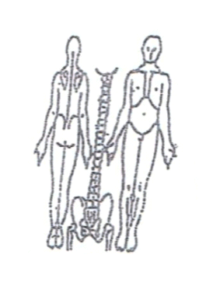 **Working Diagnosis:** Painful obstruction syndrome at the back neck area headache due to accident and QI and blood stagnation. KI QI deficiency , internal cold.

S: Patient is complaining with chronic headache, poor sleep, memory and concentration . Pain at the back with movement. ROM. Sleep disturbances.

O:

**Treatment (P)** Acupuncture: local UB 25, UB 54, UB 58, UB 60, UB 62 bilaterally with tonification for 30-40 minutes, after the peripheral needle sedation for 10-15 min. Warm up needles at the main tonification. Points of the body + Moxibition. SP 6(B), KI 3(L,R), K 6(L,R), K 4(LR), H7(LR), P6(LR), ST36(LR), SP9(LR), SP8(LR), UB7(LR), UB4(LR) with tonification. Du 20 with 4 extra 21 points with tonification method.

* Acupuncture 1 h according to the protocol.

**Date:_November 11, 2015_______________**

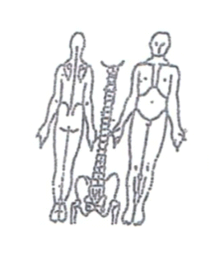**Working Diagnosis:**

S: Patient is sleeping better. Still having a dull headache, worsening at the evening time. Pain at the back area 3-4 on the pain scale. Poor memory and concentration.

O:

Treatment (P) Acupuncture with Moxibition 1 hr. according to the protocol.

(A)

**Date:_ November 14, 2015______________**

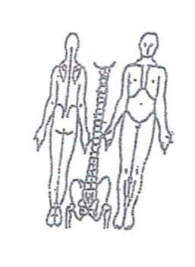**Working Diagnosis:**

S: Patient had N sleep, feeling more energized. level of headache intensity. appetite. ROM . pain at the back area. muscle stiffness. Better movement.

O:

Treatment (P) Acupuncture with warm needles at the upper C6-C7 and lower back area L3-L4-1 hour.

(A)

**Date:_ November 18, 2015_____________**

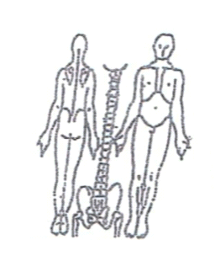**Working Diagnosis:**

S: Patient is more sharp and energized, good appetite. N ROM. Still have pain at

the back area at the end of the day.

O:

Treatment (P) Acupuncture + Moxibition 1 hour according to the protocol.

(A)

**Daily Charting____________________________________Patient Name:**

**Date:_ November 21, 2015**

**Working Diagnosis:**

S: Patient is more energized, good appetite. N ROM. Still have pain at the back area at the end of the day.

O:

Treatment (P) Acupuncture + Moxibition 1 hour according to the protocol.

(A)

**Date: November 25, 2015**

**Working Diagnosis:**

S: Patient is more energized, good appetite. N ROM. Still have pain at

the back area at the end of the day.

O:

Treatment (P) Acupuncture + Moxibition 1 hour according to the protocol.

(A)

**Date: November 28, 2015**

**Working Diagnosis:**

S: Sleep N. Energy level N. ROM N. No pain at the back area, light headache at the end of the day. Patient is more proactive and better mood.

O:

Treatment (P) Acupuncture+Moxa 1 hour, started the muscle strengthening exercises for 10-15 min.

(A)